

**A report on**

**“**ACADEMATES **–** YOUR PATH TO PERSONALIZED LEARNING**”**

**Submitted in partial fulfilment for the award of the degree of**

BACHELOR OF TECHNOLOGY

**IN**

**COMPUTER ENGINEERING**

**(SOFTWARE ENGINEERING)**

**Submitted by**

**SACHIN SINGH**

**(20BTRCS170)**

**MANISH YADAV**

**(20BTRSE037)**

**AAYUSHMA THAPA**

**(20BTRSE072)**

**SAMYAK MAHARJAN**

**(20BTRSE076)**

**Under the guidance of Prof. Karthikeyan S**

Faculty of Engineering & Technology

**Jain (Deemed-To-Be University)**

**Department of Computer Science and Engineering**

Jain Global Campus, Kanakapura Taluk – 562112

Ramanagara District, Karnataka, India

2023-2024

**Department of Computer Science and Engineering**

Jain Global Campus, Kanakapura Taluk - 562112 Ramanagara District, Karnataka, India

# CERTIFICATE

This is to certify that the project work titled **“Academates”** is carried out by **Sachin Singh (20BTRCS170), Manish Yadav (20BTRSE037), Aayushma Thapa (20BTRSE072)** and **Samyak Maharjan (20BTRSE076)** a Bonafede students of Bachelor of Technology in **Computer Engineering (Software Engineering)** at the Faculty of Engineering & Technology, Jain (Deemed-to-be University), Bangalore in partial fulfilment for the award of degree, Bachelor of Technology in Computer Engineering (Software Engineering) during the Academic year **2023-2024**.

|  |  |  |
| --- | --- | --- |
| **Prof. Karthikeyan S** Guide  Assistant Professor,  Dept. of CE-SE,  Faculty of Engineering & Technology,  Jain (Deemed-to-be University)  Date: | **Prof. Santhosh S** Program Head,  Dept. of CE-SE  Faculty of Engineering & Technology,  Jain (Deemed-to-be University)  Date: | **Dr. Geetha G**  Director,  School of Computer Science & Engineering,  Jain (Deemed- to-be University)  Date: |

**Name of the Examiner Signature of Examiner**

1.

2.

# DECLARATION

We**, Sachin Singh (20BTRCS170), Manish Yadav (20BTRSE037), Aayushma Thapa (20BTRSE072),** and **Samyak Maharjan (20BTRSE076)** are students of seventh semester **B. Tech** in **Computer Engineering** (**Software Engineering),** at Faculty of Engineering and Technology, **Jain (Deemed- To-Be) University,** hereby declare that the project centric learning work titled **“Academates”** has been carried out by us and submitted in partial fulfilment for the award of degree in **Bachelor of Technology** during the academic year **2023-2024.** Further, the matter presented in the project has not been submitted previously by anybody for the award of any degree or any diploma to any other University, to the best of our knowledge and faith.

|  |  |
| --- | --- |
| Sachin Singh  (20BTRCS170) | Signature |
| Manish Yadav  (20BTRSE037) | Signature |
| Aayushma Thapa  (20BTRSE072) | Signature |
| Samyak Maharjan  (20BTRSE072) | Signature |

Place: Bangalore

Date:

# ACKNOWLEDGEMENT

*It is a great pleasure for us to acknowledge the assistance and support of a large number of individuals who have been responsible for the successful completion of this project work.*

*First, we take this opportunity to express our sincere gratitude to* ***Faculty of Engineering and Technology, Jain (Deemed-to-be) University,*** *for providing us with a great opportunity to pursue our Bachelor’s Degree in this institution.*

*In particular we would like to thank* ***Dr. Geetha G, Director, School of Computer science and Engineering, Jain (Deemed-to-be University),*** *for her constant encouragement and expert advice.*

*It is a matter of immense pleasure to express our sincere thanks to* ***Mr. Santhosh S, Program Head, Department of Computer Engineering (Software Engineering), Jain (Deemed-to-be University),*** *for providing the right academic guidance that made our task possible.*

*We would like to thank our internal guide* ***Mr.* Karthikeyan *S, Department of Computer Engineering (Software Engineering), Jain (Deemed-to-be University),*** *for sparing his valuable time to extend help in every step of our project work, which paved the way for smooth progress and fruitful culmination of the project.*

*We are also grateful to our family and friends who provided us with every requirement throughout the course.*

*We would like to thank one and all who directly or indirectly helped us in completing the Project work successfully.*

***Signature of Students***

1. *Sachin Singh (20BTRCS170)*
2. *Manish Yadav (20BTRSE037)*
3. *Aayushma Thapa (20BTRSE072)*
4. *Samyak Maharjan (20BTRSE076)*

**Table of Contents**

**CERTIFICATE ii**

**DECLARATION iii**

**ACKNOWLEDGEMENT iv**

**ABSTRACT vii**

**CHAPTER – 1 1**

**INTRODUCTION 1**

1.1. Overview 1

1.2. Problem Definition 3

1.3. Objective(S) 3

1.4. Methodology 4

1.5. Hardware and Software Used 5

**CHAPTER – 2 6**

**LITERATURE SURVEY 6**

2.1. Existing Work 12

2.2. Limitation of Existing Works 12

2.3. Proposed Methodology 13

**CHAPTER – 3 16**

**SYSTEM DESIGN 16**

3.1. Architecture Diagram 16

3.2. Use-Case Diagram 17

3.3. Activity Diagram 19

3.4. Sequence Diagram 21

**CHAPTER – 4 23**

**TOOLS DESCRIPTION 23**

4.1. Hardware Requirements: Description 23

4.2. Software Requirements: Description 23

**CHAPTER – 5 25**

**IMPLEMENTATION 25**

5.1. Implementation Description 25

**REFERENCES** 30

# ABSTRACT

Academates is an innovative online education platform designed to bridge the gap between teachers and students. With a user-friendly interface built on React, teachers can register, create detailed profiles, and specify their expertise in subjects and topics. Students, in turn, can search for teachers based on their learning needs, viewing a curated list complete with teacher ratings. The platform facilitates seamless appointment scheduling with integrated video meetings featuring a whiteboard and screen sharing options. Payment transactions are securely processed through the platform, with a percentage allocated as the platform's service fee. Academates prioritize user security and data privacy, implementing encryption and compliance with relevant regulations. The scalability and responsive design of the platform ensure a seamless experience across devices. Marketing strategies will be employed to attract a diverse user base, establishing Academates as a leading hub for quality online education. With a robust rating and review system, Academates aims to foster a thriving educational community, offering a dynamic, secure, and personalized learning experience for both teachers and students.

# 

# CHAPTER – 1

## **INTRODUCTION**

In an era where digital connectivity is shaping the future of education, Academates emerges as a pioneering online platform designed to bridge the gap between passionate educators and eager learners. This innovative platform redefines the educational experience, offering a seamless avenue for teachers to showcase their expertise and for students to discover the perfect mentor for their learning journey. Academates envisions a dynamic learning environment that transcends geographical boundaries, bringing together a global community of educators and learners in pursuit of knowledge.

At the heart of Academates lies a commitment to revolutionize virtual learning. By integrating state-of-the-art video conferencing technology with collaborative features like a virtual whiteboard and screen sharing, we aim to create an immersive and interactive learning space. This ensures that lessons are not only informative but also engaging, allowing students to actively participate in their own educational journey. With these tools, Academates seeks to empower both teachers and students, facilitating a more effective and enriching learning experience.

Moreover, Academates places a premium on transparency and trust. Through a robust rating and review system, students can make informed decisions when selecting their educators, while teachers have the opportunity to showcase their proficiency and dedication. Secure payment processing further reinforces the platform's commitment to integrity, ensuring that financial transactions are conducted smoothly and reliably. As we embark on this educational journey, Academates envisions a future where quality education is accessible to all, irrespective of geographical or economic constraints, redefining the way we learn and grow in the digital age.

## **Overview**

The Academates platform offers a comprehensive solution for connecting teachers and students in a dynamic online learning environment. At its core, the platform serves as an intermediary, facilitating seamless interactions between educators and learners across a wide array of subjects and topics.

1. **User Profiles**: Teachers create detailed profiles, showcasing their qualifications, expertise, and availability. Students can browse through these profiles to find the perfect match for their learning needs.
2. **Search and Matchmaking:** Students can search for teachers based on specific subjects, topics, and expertise. The platform employs advanced algorithms to suggest compatible educators, ensuring optimal matches for a tailored learning experience.
3. **Interactive Virtual Classroom:** Academates offers a robust video conferencing system complete with a virtual whiteboard and screen sharing capabilities. This facilitates real-time, interactive learning sessions, providing students with an engaging educational experience.
4. **Appointment Scheduling:** Teachers set their availability through a user-friendly calendar interface, allowing students to book lessons at their preferred times. This streamlines the scheduling process and ensures both parties are in sync.
5. **Rating and Review System:** Students have the opportunity to rate and leave reviews for their teachers after each session. This system helps maintain transparency and accountability, fostering a community of high-quality educators.
6. **Secure Payment Processing:** The platform integrates a secure payment gateway for hassle-free financial transactions between students and teachers. A defined platform service fee ensures transparent and reliable payment handling.
7. **Mobile Responsiveness:** The platform is designed to be accessible on various devices, including desktops, tablets, and mobile phones, ensuring users can engage in learning wherever they are.
8. **Data Security and Privacy:** Academates employs robust security measures to safeguard user data, adhering to relevant data protection regulations and ensuring the confidentiality of all user information.

As Academates continues to evolve, future enhancements may include AI-driven matching algorithms, multi-language support, advanced analytics, certification verification, and integration with existing Learning Management Systems (LMS). These additions aim to further enrich the learning experience and expand the platform's capabilities. With a vision to revolutionize online education, Academates is poised to redefine how knowledge is accessed and shared, offering a dynamic, secure, and personalized learning experience for both teachers and students.

## **Problem Definition**

In the rapidly evolving landscape of education, there exists a significant gap between qualified teachers and eager learners seeking personalized instruction. Traditional avenues of finding and engaging with educators are often cumbersome and lack transparency in terms of teacher proficiency and availability. Additionally, the absence of a seamless virtual learning environment with integrated collaboration tools inhibits effective remote instruction. To address these challenges, Academates endeavors to create a user-centric online platform that connects teachers and students, streamlining the process of discovering, scheduling, and conducting virtual lessons while ensuring transparency, security, and quality education. This platform will serve as a transformative intermediary in the education sector, revolutionizing the way knowledge is accessed and shared in the digital age.

## **Objective(S)**

The primary goal of the Academates platform is to establish a seamless and interactive online learning ecosystem, bridging the gap between educators and students worldwide. By providing a user-friendly interface for teachers to showcase their expertise and for students to discover tailored learning opportunities, Academates aims to revolutionize the way knowledge is accessed and shared. The platform's cutting-edge video conferencing technology, integrated whiteboard, and screen sharing capabilities foster an engaging virtual classroom experience, ensuring lessons are not only informative but also interactive. Through transparent rating and review systems, Academates seeks to create a trustworthy community, empowering both educators and learners to actively participate in their educational journeys.

The specific objectives of the Academates project can be outlined as follows:

* Facilitate seamless connections between teachers and students, enhancing the accessibility and availability of personalized learning opportunities.
* Provide an immersive virtual classroom experience through integrated video conferencing, whiteboard, and screen sharing functionalities.
* Establish a transparent and trustworthy learning environment with a robust rating and review system for both teachers and students.
* Streamline appointment scheduling and lesson bookings, ensuring a smooth and efficient learning experience for all parties involved.
* Implement secure payment processing with a defined platform service fee, safeguarding **financial transactions while sustaining the platform's operations and growth.**

## **Methodology**

Academates will be developed as a web-based application using modern web technologies. The front-end will be built using the React framework, providing a dynamic and responsive user interface. For the back-end, Node.js with Express will be employed to handle server-side logic and API endpoints. Data will be managed using a relational database, and MongoDB will be utilized for its robustness and scalability. The platform will incorporate WebRTC technology for video conferencing, allowing real-time interactions between teachers and students. Additionally, a secure payment gateway, such as Stripe, will be integrated for seamless financial transactions. The application will be hosted on a reliable cloud platform, ensuring scalability and availability.

The development of Academates will follow an agile methodology, allowing for iterative and incremental progress. The project will commence with detailed requirements gathering and system design, outlining the core features and functionalities. Following this, the team will work in sprints, focusing on specific components and functionalities in each iteration. Continuous integration and automated testing will be implemented to maintain code quality and stability. Regular user testing and feedback loops will be incorporated to validate the application's usability and address any user-centric concerns. The development process will prioritize security, implementing measures such as secure authentication, data encryption, and regular security audits. Additionally, the platform will adhere to relevant data protection regulations, ensuring the confidentiality and privacy of user information.

Upon completion of development, the application will undergo extensive testing, including unit testing for individual components, integration testing for system interactions, and user acceptance testing to ensure the platform meets the specified requirements. Deployment will be carried out on a reliable web hosting service, with consideration for scalability and load balancing to accommodate potential spikes in user traffic.

Through this iterative and user-centric development approach, Academates aims to deliver a robust and user-friendly platform that redefines the online education experience, connecting teachers and students in an engaging and interactive virtual learning environment.

## **Hardware and Software Used**

As this project is based on web-development, the required software and hardware are as follows:

1. Front-End Development:

* React: For building the user interface and ensuring a dynamic, interactive user experience.

1. Back-End Development:

* Node.js with Express.js: For handling server-side operations, managing routes, and handling database interactions.
* Database (MongoDB): To store user information, teacher profiles, subjects, appointments, reviews, and more.

1. Database Management:

* MongoDB: For structured data management, querying, and retrieval.

1. Video Conferencing Integration:

* WebRTC: For enabling real-time video meetings between teachers and students.

1. Payment Gateway Integration:

* PayPal and UPI: To handle secure payment transactions between students and teachers.

1. Authentication and Authorization:

* JSON Web Tokens (JWT): For secure authentication and authorization of users.

1. Version Control:

* Git/GitHub: For collaborative development and version control.

1. Deployment:

* Cloud Platform (i.e., AWS): To host and deploy the application.

# CHAPTER – 2

## **LITERATURE SURVEY**

The literature survey encompasses a comprehensive review of existing research and resources pertinent to the development of Academates, an innovative online education platform. It delves into key areas such as online education evolution, user interface design, payment systems, data privacy, and marketing strategies, providing a solid foundation for the project's implementation.

The "Smart Education Platform to Enhance Student Learning Experience during COVID-19 by Naidu et al." centers on implementing Smart Education in response to the growing demand for advanced learning methods, especially amidst events like the COVID-19 pandemic [1]. It underscores the pivotal role of Smart Cities in facilitating these educational strides and highlights the widespread use of tools like Zoom for online learning. While acknowledging the positive impacts of this practice in terms of flexibility, accessibility, and innovation, the paper identifies a need for improvement in learner engagement.

The paper by Truong & Diep highlights the vital role of digital transformation in today's globalized tertiary education landscape, advocating for educational institutions to embrace innovative, cost-effective approaches through recent technological advancements [2]. Employing a systematic review methodology following PRISMA guidelines, the paper identifies relevant literature on technology's impact on reshaping tertiary education. While effectively spotlighting key technological trends such as Artificial Intelligence, Internet of Things, blockchain, and various platforms (like social networks, Mobile platforms, Big data analytics), it could delve deeper into their practical implementation in education and provide more specific strategies for educators and institutions to leverage these trends

The paper by Rai et al. conducts a comparative study on implementing innovation in the education sector in response to the COVID-19 pandemic, highlighting its adaptability to new technologies and methodologies [3]. It emphasizes flexibility in catering to the needs of students, parents, and government, with a focus on the crucial role of technologies like video meetings, online teaching, and digital platforms in driving online education growth. While the paper mainly concentrates on conceptual and historical aspects, it could benefit from incorporating specific case studies or empirical data to demonstrate practical implementation and impact. It also could explore potential challenges associated with rapid digital transformation.

The idea by wang & wang explores the dynamic landscape of e-learning, recognizing the diverse nature of online information in the internet age. To enhance user intention and learning performance, the study integrates Kolb's experiential learning cycle into an e-learning platform, emphasizing modern interface design[4]. The platform's planning and design prioritize usability and user experience, aiming to facilitate interdisciplinary learning, reduce learning thresholds, and enhance overall learning outcomes. A potential drawback is the paper's general focus on the importance of usability and user experience without specific implementation details. Additionally, it lacks empirical evidence or case studies demonstrating the proposed approach's impact on learning performance.

The article by Lei et al., introduces a unified and flexible experimental framework for massive online experimentation in control education, employing a front-end and back-end separation scheme based on React and Nginx [5]. This architecture creates a single-page application for an enhanced user experience. The framework integrates features and supporting technologies to offer a flexible, interactive, and real-time platform for control education, covering online algorithm design, web-based algorithm design, parameter tuning, and real-time control with remote and virtual laboratories. While the article primarily focuses on the technical aspects, it lacks detailed insights into user experience or specific implementation examples.

The project by Darvin et al. explores the integration of technology in education, specifically emphasizing Learning Management Systems (LMS) [6]. LMS, crucial for supporting teaching and learning activities, is examined with a focus on the paramount importance of effective user interface (UI) design and user experience (UX). The study identifies common methods for UI and UX evaluation, such as usability measurement and heuristic evaluation, while underscoring the significance of features like discussion forums and learning materials within an LMS. However, a potential drawback is the lack of specific examples or insights into the methods for usability measurement and heuristic evaluation, along with insufficient details on challenges in LMS development.

The main idea of the paper "Attaining 21st Century Skills in a Virtual Classroom" revolves around how virtual classrooms can be strategically used to develop the "Four Cs" of 21st century skills — communication, collaboration, critical thinking, and problem solving, and creativity. It argues that, using various digital resources, online learning environments can potentially offer more in terms of attaining and becoming proficient in these skills than traditional classrooms [7]. Although the paper outlines a range of digital resources to enhance virtual learning, it may underrepresent the challenges of integrating technology into teaching and ensuring equitable access for all students. Additionally, it does not adequately address the potential for reduced personal interaction and the nuances of in-person feedback, which are critical components of the learning experience.

The paper, "The Importance of Interaction Mechanisms in Blended Learning Courses Involving Problem-Solving E-tivities," focuses on identifying interaction mechanisms that enhance collaborative problem-solving in blended learning. It advocates for a collaborative space using tools like GitHub and traditional Learning Management Systems (LMS) to improve student project quality and outcomes [8]. The study, conducted within a "Project Management: a look ahead" course, reports positive impacts on student engagement and learning outcomes through the implemented mechanisms. However, a drawback is its specificity, providing interaction requirements tailored to a particular course setup and platforms (GitHub and Moodle). This specificity may limit universal applicability or adaptability to diverse educational settings. Additionally, the paper might not fully address the potential learning curve associated with these platforms, potentially hindering generalizability, or ease of adoption in other educational contexts.

The study by Liu et al. aims to design and implement a virtual reality classroom using the Online Merge Offline (OMO) concept, facilitated by WebXR technology. This virtual reality classroom strives to offer an immersive and realistic experience for teachers and students, enabling interaction across multiple devices. Two scenes simulating classroom and discussion room settings have garnered positive feedback from university students and instructors [9]. However, a potential drawback is the study's lack of specific details about implementation challenges or any potential drawbacks or limitations of the virtual reality classroom.

The paper by Kostoski & Apostolova underscores the increasing significance of secure online payment processing systems for e-commerce businesses, introducing "Payatron" as a custom-developed solution. Payatron is designed to ensure swift and secure transactions, aiming to minimize complaints and expedite the delivery of goods. The paper focuses on the evolving global landscape of online transactions and emphasizes the pivotal role that secure payment procedures play in fostering customer loyalty [10]. Academates can apply the insights from this paper by integrating secure online payment processing features. Implementing a robust and reliable payment system, inspired by the principles outlined in the paper, would enhance the user experience for both students and educators on the platform. The incorporation of fast and secure transactions is crucial for the success and trustworthiness of any online platform, and Academates can adopt such features to provide a seamless and trustworthy transaction experience for its users.

The paper by Baibhav et al. introduces the Payment Tracking System (PTS), a sophisticated web-based platform for efficient tracking and management of vendor payments. Acting as a centralized hub, PTS consolidates payment requests and ensures timely supplier payments through integrated best practices. Advanced features like Invoice Generation and Payment Reminders offer visibility into financial transactions, addressing challenges in today's business environment [11]. Academates can enhance its financial processes by drawing inspiration from PTS, streamlining payment workflows and providing users with visibility and control over their financial interactions. Integrating features like Invoice Generation and Payment Reminders ensures a smooth and reliable financial experience for educators and students on the platform.

The paper “unified Payment Interface – An advancement in payment system” by Gochhwal explores the Unified Payment Interface (UPI), a transformative mobile-centric, real-time interbank payment system in India. It traces the evolution of payment systems, highlighting UPI's role in universalizing digital payments. The study delves into UPI's technology, emphasizing its architecture and security systems[12]. UPI is recognized for its advancements in cost, consumer ease, settlement times, and security, experiencing significant user adoption. Academates can apply UPI insights to enhance its payment infrastructure, streamlining processes for educators and students. By integrating a mobile-centric, real-time payment system, Academates can improve user experience, offering efficient transactions within the platform. Developing merchant-centric UPI solutions aligns with financial inclusion goals, fostering a low-cost digital payment ecosystem and enhancing platform accessibility.

The paper “Data Security and Protection: A Mechanism For Managing Data Theft and Cybercrime in Online Platforms Of Educational Institutions” addresses the escalating threat of cybercrime and online data theft in educational institutions due to the widespread adoption of information systems and online platforms. It emphasizes the need for robust data security and protection mechanisms to safeguard sensitive information related to fees and academic records. The study conducts empirical research on data security issues and cyber threats within educational institutions. The paper advocates for the implementation of a comprehensive security model to prevent unauthorized access and data distortion. Additionally, it recommends awareness campaigns for students and staff to mitigate the risks of exposure to malicious users on online platforms [13].

The paper “Data Privacy Protection from the Perspective of GDPR - A Case Study on E-learning Platform “SHCneo” focuses on safeguarding privacy on E-Learning Platform "SHCneo," a collaboration between Chinese and German universities, by strictly adhering to the General Data Protection Regulation (GDPR) in the EU. Addressing the rising concerns of privacy breaches on E-Learning platforms, the study employs SHCneo as a case study to analyze GDPR's personal data privacy protection features. It aims to enhance data privacy security in online learning systems and outlines measures for data privacy protection. The paper underscores the importance of stringent data security measures, especially in educational institutions utilizing online platforms, to prevent cybercrimes and unauthorized access to sensitive information [14].

The article “Securing e-learning platforms” addresses the crucial issue of security in the context of the growing popularity of e-learning. As e-learning gains traction, ensuring robust security measures becomes paramount. The paper highlights key security considerations such as access control, authentication, data integrity, and content protection. It emphasizes the use of information security tools like cryptography and network protocols to safeguard e-learning platforms. Focusing on an open-source e-learning system, the paper examines security aspects and outlines challenges in the development and usage of e-learning platforms. It underscores the multifaceted nature of security management, especially concerning content, services, and personal data for both external and internal users [15].

The paper investigates the impact of user rating behavior on review helpfulness, addressing the evolving landscape of online reviews and the interests of both businesses and reviewers. The study introduces and modifies features for businesses and reviewers, proposing a user-centric mechanism for review selection [16]. Through a comprehensive analysis of a Yelp dataset, the research identifies changes in business reputation, user choice patterns, and rating behaviors. Notably, 46% of users prefer businesses with a minimum of 4 stars, and 60% of reviewers exhibit irregular rating behavior. The study emphasizes the importance of features such as reviewer popularity, experience, and various user behaviors in determining review helpfulness. For web app academies, this research offers valuable insights into understanding user behaviors, aiding in the development of platforms that enhance the relevance and usefulness of online reviews of the teachers.

The paper “Student Satisfaction and Churn Predicting using Machine Learning Algorithms for EdTech course” addresses student churn in EdTech courses amid increased competition and reduced quality during the COVID-19 pandemic. It proposes machine learning algorithms, specifically K-Nearest Neighbor (KNN) and Support Vector Machines (SVM), to predict churn based on course-end survey feedback. Using a real-time dataset from Zikshaa, an EdTech startup, the model identifies dissatisfied students, allowing personalized interventions for course improvement [17]. Web app academies can apply this methodology to predict and address student dissatisfaction, enhancing course quality and customization. By integrating predictive analytics, academies prioritize user experience, reduce churn rates, and foster sustained growth through improved customer retention.

The paper by Birari et al. conducts sentiment analysis on 600 reviews from MouthShut.com to explore user perceptions on three major EdTech platforms amid the Covid-19 pandemic. Analyzing sentiments related to faculty expertise, user-friendliness, syllabus, and pricing model reveals positive user sentiments toward EdTech services [18]. The research provides valuable insights for EdTech service providers to optimize their strategies and offerings, attracting and retaining consumers in the evolving educational landscape. Web app academies can apply these findings to understand user sentiments, optimizing their platforms for enhanced experiences. Conducting similar sentiment analyses on user reviews enables academies to identify areas for improvement and strategically position themselves in the competitive EdTech landscape, contributing to increased user satisfaction and sustained engagement.

## **Existing Work**

There are several online platforms that provide services similar to what Academates offers. Some well-known examples include:

* **Udemy**: Udemy is a popular online learning platform that connects instructors with students. It offers a wide range of courses on various subjects, and instructors can create and upload their own courses.
* **Coursera**: Coursera partners with universities and organizations to offer a variety of courses, specializations, and degrees. It includes video lectures, assignments, and forums for discussion.
* **edX**: Like Coursera, edX provides access to courses and programs from universities and institutions around the world. It covers a wide range of subjects and offers both free and paid options.
* **Skillshare**: Skillshare is a platform that focuses on creative skills. It offers a range of classes in areas like design, photography, writing, and more.
* **Chegg Tutors**: Chegg connects students with tutors for one-on-one lessons in various subjects. The sessions can be conducted online, and students can choose tutors based on their profiles.
* **Wyzant**: Wyzant is a platform that allows students to find and connect with private tutors for in-person or online lessons in a wide range of subjects.

## **Limitation of Existing Works**

While existing online learning applications offer convenience and streamline the process of online teaching and learning, they may have certain limitations. Here are some common limitations associated with existing personalized online learning platforms:

1. **Lack of Personalization**: Many platforms only have pre-recorded lectures that may not be useful for the students who have doubt in some specific topic. There is not live interaction between students and teachers.
2. **Quality Control**: Ensuring the quality of course content and the effectiveness of teaching methods can be difficult on large platforms where anyone can create and publish courses. Maintaining consistent quality standards is an ongoing challenge.
3. **Limited Interactivity**: Some platforms may lack interactive elements, such as live discussions, real-time collaboration tools, or hands-on projects, which are crucial for certain subjects and teaching styles.
4. **Instructor Credibility**: On platforms where anyone can become an instructor, ensuring the credibility of the educators may be a concern. Students might face challenges in evaluating the qualifications and expertise of instructors.
5. **Limited Hands-On Learning**: Some subjects require hands-on experience, and it can be challenging to replicate this in an online environment. Practical or lab-based courses may face limitations in providing a fully immersive experience.
6. **High Competition:** The market for online education is saturated, leading to high competition among instructors and platforms. Standing out and attracting a significant user base can be challenging.

## **Proposed Methodology**

In addressing the challenges identified in the dynamic landscape of online education, Academates proposes a comprehensive methodology to revolutionize the teacher-student interaction. Following the project introduction, Academates aims to overcome obstacles by creating an intuitive and transparent platform for educators and learners. The platform will seamlessly connect teachers and students, providing a personalized and interactive virtual classroom experience. Through the integration of cutting-edge video conferencing tools, a collaborative virtual whiteboard, and secure payment gateways, Academates ensures an efficient and secure learning environment. A robust rating system enhances transparency, and future developments, including AI-driven matching and multi-language support, further position Academates to evolve with the ever-changing needs of the education sector. By prioritizing user experience, security, and innovation, Academates aspires to redefine online education, making quality learning accessible to a global audience.

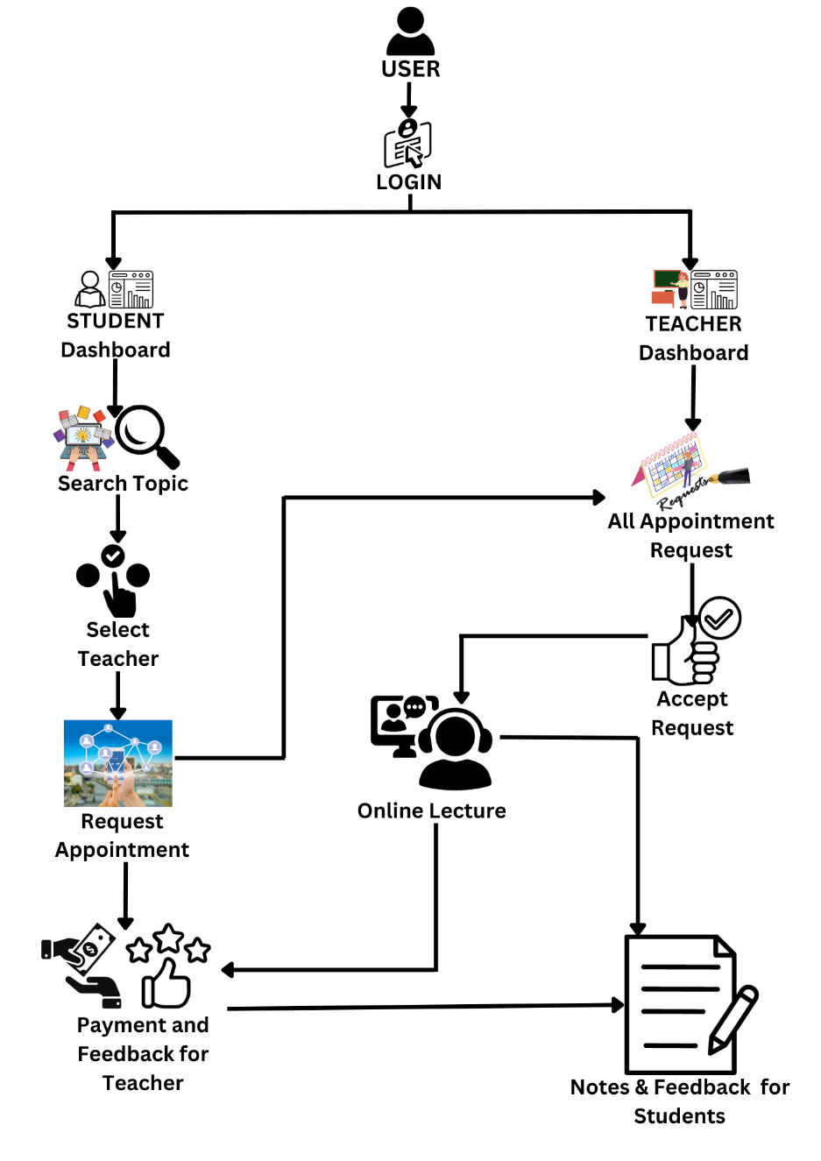

*Fig 2.3.1 System Architecture Diagram of Academates*

In Fig. 2.3.1, The diagram depicts the workflow for the Academates project, illustrating the user journey from login to post-lecture activities. Users, categorized as students or teachers, log in to their respective dashboards. Students can search for topics and select teachers based on their preferences, proceeding to request appointments. Teachers view all appointment requests on their dashboard and accept them as appropriate. Once an appointment is accepted, an online lecture takes place. After the lecture, students can make payments and provide feedback for the teacher. Additionally, teachers can provide notes and feedback for the students, closing the loop of an interactive educational session.

**Teacher Side**

Step 1: Teacher login

Step 2: Teacher opens his profile.

step 3: Teacher checks the lecture requests.

step 4: If lecture request is there, teacher accept or decline the request.

step 5: After accepting, teacher can come back on the accepted time and take class.

step 6: Add feedback about the students.

step 7: Get the payment.

**Student side**

Step 1: Student login

Step 2: Search for the desired lecture from the available teachers

Step 3: Submit a lecture request to the teacher.

Step 4: Wait for the teacher to accept or decline the request.

Step 5: If the request is accepted, be present at the scheduled time for the class.

Step 6: Participate actively in the class and take notes.

Step 7: After the class, review the feedback provided by the teacher, if any and provide feedback to the teacher for overall studying experience.

Step 8: Make the payment for the attended class.

Step 9: Cheak own profile for the progress.

# CHAPTER – 3

## **SYSTEM DESIGN**

## **Architecture Diagram**

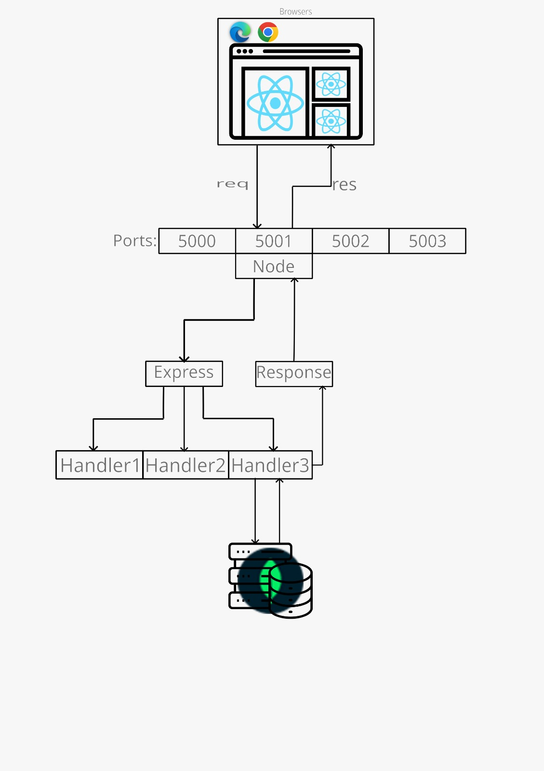

*Fig 3.1.1: Architecture Design of Academates*

In Fig 3.1.1, The architecture diagram illustrates the structure of the Academates web application, showcasing the interaction between client-side and server-side technologies. The process begins with the user interacting with the application through a web browser, where the React framework, known for its efficient rendering of user interfaces, powers the frontend. This React application communicates with the server using HTTP requests.

On the server side, Node.js is utilized as the runtime environment, capable of executing JavaScript code outside of a browser. It listens on multiple ports for incoming requests from the client side. Express.js, a web application framework for Node.js, is employed to streamline the creation of server-side logic and APIs. It is responsible for handling web requests and responses, organizing the backend structure with middleware and routing.

The diagram displays a series of handlers within Express.js, each designed to process specific types of requests, perform the necessary business logic, and interact with the database as needed. These handlers are critical in managing CRUD (Create, Read, Update, Delete) operations that the front-end React application requires to provide dynamic content to the user.

In this system, when a request is sent from the React application, it reaches Node.js, which delegates the request to Express.js. Express.js, through the appropriate handler, processes the request—be it querying or updating the database or performing calculations—and prepares a response. This response is then relayed back through Node.js to the React application, which updates the user interface accordingly, thus completing the request-response cycle.

The integration of React with Node.js and Express.js in the Academates application results in a seamless, real-time user experience, where changes on the frontend reflect immediately after server-side processing. This architecture supports a scalable, maintainable, and efficient web application, allowing Academates to deliver a robust online educational platform.

## **Use-Case Diagram**

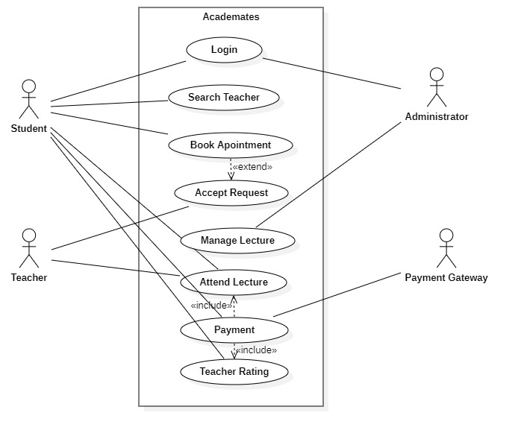

*Fig 3.2.1: Use-Case Diagram of Academates*

The use case diagram for Academates portrays a comprehensive system that facilitates a variety of educational interactions between different users and the platform. At its core, the system allows students to log in and search for teachers, reflecting the primary action that initiates the user's journey. The process of booking appointments with teachers is elaborated upon with an extension indicating that teachers have the ability to accept these appointment requests. This reflects a two-step interaction where students propose a time for learning, and teachers confirm their availability, ensuring a mutual agreement before a lecture is scheduled.

The 'Attend Lecture' use case is central to the student's experience and is depicted as including both 'Payment' and 'Teacher Rating', signifying these actions as integral parts of attending a lecture. Payments are processed through an external 'Payment Gateway', which suggests that the financial transactions are securely managed by a third-party service, ensuring the safety and reliability of monetary exchanges on the platform.

Teachers have a distinct set of interactions with the system, primarily 'Manage Lecture', which encapsulates the preparation and delivery of educational content. This indicates a level of autonomy and responsibility on the teacher's part, emphasizing the platform's role as an enabler of educational delivery rather than just a mediator.

The presence of an 'Administrator' hints at oversight and management capabilities within Academates, suggesting that there is a control mechanism to maintain the platform's integrity and operational efficiency. It subtly implies that while the platform is driven by the direct interactions of students and teachers, there is also a regulatory role in play to oversee these interactions and ensure they adhere to the standards of the service.

This diagram effectively communicates the dynamic and interactive nature of the Academates platform, showcasing a system designed to cater to the varied needs of its users through well-thought-out functionalities that support an engaging and comprehensive online educational experience.

## **Activity Diagram**

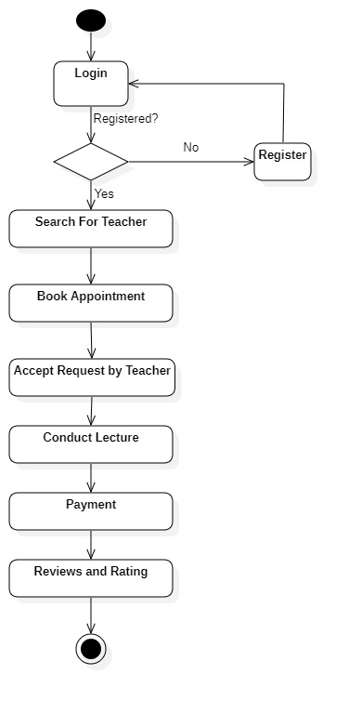

*Fig 3.3.1: Activity Diagram of Academates*

The activity diagram for Academates outlines the procedural flow of user engagement with the platform, beginning with the login procedure. It starts with a decision node that checks if the user is already registered. For unregistered users, the flow directs them to complete the registration process before proceeding. Once authenticated, users enter the core functionality of the platform, starting with searching for a teacher. After locating a suitable educator, they can book an appointment, which is subject to acceptance by the teacher. The successful booking leads to the actual educational exchange—the lecture conducted by the teacher.

Subsequent to the lecture, the payment activity is triggered, signifying the platform's integrated financial transaction capability. This is a crucial point in the process, reflecting the system's support for secure online payments. The final step in the user’s journey within Academates is the review and rating system, where students can provide feedback on their educational experience. This step completes the loop, ensuring quality control and community trust in the platform.

The depicted flow is essential for maintaining the order of operations within Academates, ensuring that each step is completed in sequence for a smooth user experience. The activity diagram serves as a blueprint for both developers and users, illustrating the platform's intended use and providing a guide for navigating its features. This systematic approach to visualizing user interactions highlights the focus on an intuitive and structured user journey, which is key to the platform's success in delivering educational services efficiently.

## **Sequence Diagram**

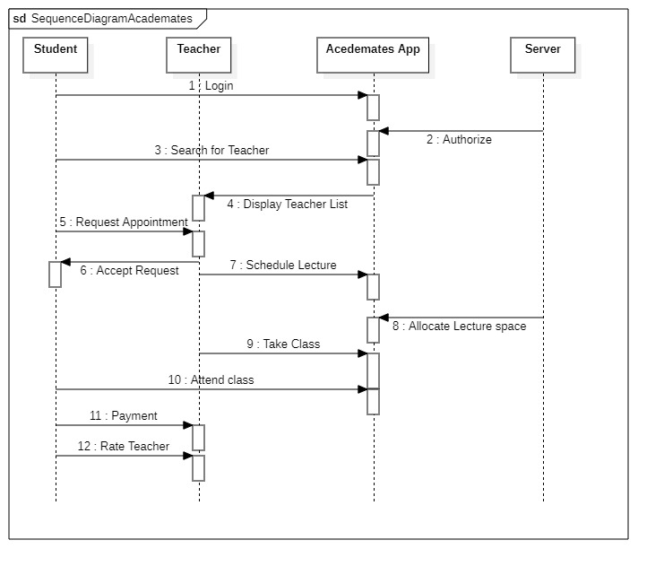

*Fig 3.4.1: Sequence Diagram of Academates*

The sequence diagram for the Academates application delineates a systematic flow of interactions between the system’s actors and the backend server, encapsulating a complete educational transaction. It commences with a student initiating the session by logging into the system, which prompts a security authorization from the server to verify credentials. Once authenticated, the student proceeds to search for a teacher, an action that triggers the server to retrieve and display a list of available teachers.

The student selects a teacher from the list and requests an appointment, sending a notification to the teacher's interface. The teacher, upon reviewing the request, either accepts or rejects it. Acceptance of the request leads the server to schedule the lecture and reserve the necessary virtual space for the class. This reservation confirms the allocation of resources required for a smooth educational session.

At the scheduled time, the student attends the class, indicating that the session is active, while the teacher takes the role of conducting the class. The teacher's acceptance of the class session bridges the interaction between teaching and learning, where the server acts as an intermediary to ensure the provision of content and resources.

Upon the conclusion of the class, the student proceeds to the payment process, facilitated by the server, which ensures the secure transaction of funds in exchange for the educational services rendered. As a final step, the student is presented with an option to rate the teacher, which is a critical feedback mechanism that maintains the quality and integrity of the Academates platform.

The sequence diagram encapsulates the collaborative nature of the Academates system, highlighting the interdependent steps that create a cohesive user experience. From login to lecture completion, each step is interconnected, reflecting a robust and user-centered approach to virtual education, where each action prompts a response that advances the sequence of educational engagement.

# CHAPTER – 4

## **TOOLS DESCRIPTION**

## **Hardware Requirements: Description**

The Academates platform is designed to be accessible and user-friendly, requiring the following hardware specifications for optimal performance:

* **RAM**: At least 2 GB for smooth operation.
* **Processor**: A modern processor (i.e., Intel i3 or equivalent), 2 GHz or faster recommended for seamless multitasking and video streaming capabilities.
* **Hard Disk Space**: A minimum of 10 GB free space to accommodate application files and additional resources.
* **Supported Devices**: Compatibility with both Android and iOS devices for mobile accessibility.
* **Network Connection**: Stable internet connection with a network adapter for uninterrupted connectivity.
* **Graphics Display**: High-definition graphics display for clear and engaging visual content.
* **Peripheral Support**: Compatibility with various peripherals like webcams and headsets for interactive sessions.

## **Software Requirements: Description**

Academates utilizes a versatile set of software components, ensuring comprehensive access and development flexibility: 4.2.1. Operating System Requirements

* **For Users**: Support for recent versions of macOS and Windows (Windows 10 and above), as well as recent Android and iOS versions for mobile users. 4.2.2. Client-side Software Requirements
* **Web Browsers**: Latest versions of Google Chrome, Mozilla Firefox, and Safari for reliable and secure access to the platform. 4.2.3. Developer Libraries and Tools
* **For Development**: React for frontend development, Node.js for server-side operations, and a corresponding set of SDKs for integration of services such as payment gateways and video conferencing tools.
* **Database**: Use of MongoDB or a similar NoSQL database for efficient data storage and retrieval.

These requirements are structured to provide both users and developers with the necessary tools and capabilities to interact with the Academates system effectively.

# CHAPTER – 5

## **IMPLEMENTATION**

## **Implementation Description**

The development of Academates is strategically segmented into distinct modules for efficiency and manageability:

**Module 1: User Interface Design**

**Module 2: Backend Development**

**Module 3: Database Management**

**Module 4: Integration of Services**

**Module 5: Testing and Quality Assurance**

**Module 6: Deployment and Maintenance**

**Module 1:** **User Interface Design**

This Module of the Academates platform, focused on User Interface (UI) Design, is pivotal for ensuring that users—students and teachers—experience a seamless and intuitive interaction with the application. This module entails the meticulous creation of the front-end infrastructure using React, a popular JavaScript library known for its efficiency in rendering dynamic user interfaces. The design process prioritizes responsiveness and adaptability, ensuring that the application's visual elements and navigation are consistent and functional across a wide range of devices, from desktops to smartphones.

A significant part of this module is dedicated to the development of user-centric features such as dashboard layouts, course browsing capabilities, and interactive elements for appointment scheduling. Attention to detail is crucial in crafting UI components that are not only aesthetically pleasing but also facilitate an engaging and frictionless user journey. By adhering to best practices in UI/UX design, Module 1 lays the foundational user experience that supports the educational goals of Academates, aiming to enhance learning outcomes through a thoughtfully designed digital environment.

**Module 2:** **Backend Development**

In this module of the Academates project, Backend Development, is centered on establishing a robust server-side architecture. Utilizing Node.js, a powerful JavaScript runtime, the module's focus is to construct a series of APIs that underpin the platform's functionality. These APIs cater to various features such as user authentication, where security protocols are implemented to protect user data; profile management, allowing for the creation and updating of user information; and class scheduling, which involves the logistics of setting up classes and managing attendance. Critical to this module is the integration of database operations, ensuring that data flow between the frontend and the database is seamless and efficient. This module is crucial for enabling dynamic interactions within the platform, such as signing up for classes, attending sessions, and interacting with the course material. Rigorous testing is conducted alongside development to ensure that each component is reliable and performs as expected, creating a secure and stable backend foundation for the Academates ecosystem.

**Module 3:** **Database Management**

Module 3 of the Academates implementation, centered on Database Management, is critical for maintaining the structural integrity and efficiency of the entire platform. Utilizing MongoDB, a NoSQL database, this module focuses on the creation and administration of a flexible and scalable database schema. The schema is designed to store diverse datasets, including user profiles, which encapsulate credentials, preferences, and personal information for both students and teachers. Class schedules are meticulously recorded to facilitate the planning and execution of educational sessions. Payment information is securely held, ensuring transactions are processed accurately, while feedback data is cataloged to support the continuous improvement of the platform. Essential tasks such as indexing for performance optimization, establishing relationships between different data entities, and implementing robust security measures to protect sensitive information are prioritized. The database is regularly backed up and monitored, with a recovery system in place to prevent data loss. This module is foundational, ensuring that data-driven components of the platform, such as personalized course recommendations and tracking educational progress, operate seamlessly.

**Module 4:** **Integration of Services**

This module encompasses the crucial phase where external and third-party services are incorporated into the platform to enhance functionality. This module focuses on embedding video conferencing tools, which are essential for the virtual classroom environment, enabling live interactions between students and teachers. It also includes the integration of secure payment gateways, crucial for processing transactions within the platform, allowing for seamless financial operations.

The integration process requires careful planning to ensure compatibility and security. APIs from trusted service providers are selected based on reliability, ease of use, and cost-effectiveness. Developers work to embed these services into the Academates infrastructure, writing custom code to bridge the platform with external APIs. Rigorous testing follows to ensure that these integrations work harmoniously with the existing system features, maintaining a cohesive user experience. This module is pivotal as it directly impacts the user's ability to engage in core activities of the platform. The success of this module is measured by the seamless execution of live classes and financial transactions without disruptions, thereby affirming the effectiveness of the integrated services in supporting the platform's educational offerings.

**Module 5:** **Testing and Quality Assurance**

This module of the Academates implementation, dedicated to Testing and Quality Assurance, is a critical phase where every feature of the application is meticulously tested to ensure it meets the highest standards of quality and reliability. This phase is designed to detect and resolve any bugs or inconsistencies that could affect user experience or system performance. The testing process is multi-faceted, beginning with unit testing, where individual components are tested in isolation to confirm that each part functions correctly. Integration testing follows, ensuring that different parts of the application work together as expected. User acceptance testing is then conducted, often with a group representing the end-users, to validate the overall system against the requirements.

This module also encompasses performance testing to evaluate the system’s behavior under certain conditions and load testing to measure its capabilities when handling a high number of simultaneous users. Security testing is included to safeguard user data and prevent vulnerabilities. Each test cycle provides valuable feedback that is used to refine and enhance the application, ensuring that Academates delivers a seamless, efficient, and secure learning experience upon launch.

**Module 6:** **Deployment and Maintenance**

The final module "Deployment and Maintenance," is a critical phase in the implementation of the Academates platform. This stage involves deploying the fully developed application to a production environment, which could be a cloud-based service such as AWS, Google Cloud, or Azure to ensure scalability and high availability. The deployment process includes setting up the server instances, configuring databases, and establishing continuous integration and delivery pipelines for automated deployment of updates. Once deployed, the platform enters the maintenance phase, where ongoing support ensures the system operates smoothly. This involves monitoring the application’s performance, troubleshooting any issues, applying necessary patches, and performing periodic updates to the software. Regular security audits are also conducted to safeguard against vulnerabilities. Moreover, user feedback is continually assessed, and improvements are made accordingly to enhance functionality and user experience. The focus on maintenance ensures that Academates remains reliable, secure, and up-to-date, delivering a consistent and high-quality user experience.

This modular approach allows for parallel development and simplifies the process of identifying and resolving issues, leading to a robust and scalable educational platform.

**App Component**

The Academates app consists of several key components that facilitate its functionality as an educational platform:

* **Admin-side Management**: Allows administrators to oversee all aspects of the platform, including user management and course oversight.
* **User Authentication**: Both students and teachers can register and log in to access personalized dashboards.
* **Course Catalog**: Presents a searchable list of available courses and teachers across various subjects.
* **Payment Integration**: A secure payment system for students to pay for courses and for teachers to receive compensation.
* **Classroom Management**: Teachers can manage virtual classrooms, including scheduling and resource allocation.
* **Live Streaming**: Real-time video capabilities for conducting online classes.
* **Notifications**: Automated alerts for class schedules, assignments, and updates.
* **Analytics**: Provides insights into usage patterns, popular courses, and student performance.
* **Interactive Tools**: Features like quizzes, assignments, and interactive whiteboards to enhance learning.
* **Security Protocols**: Protects user data and ensures privacy and integrity of the platform.
* **Email Integration**: Sends confirmations and communications related to course enrollments and platform updates.
* **Feedback Mechanism**: Allows users to submit feedback on courses and teaching, fostering continuous improvement.

# REFERENCES

[1] V. R. Naidu, S. Bhatia, R. Hasan, B. Singh, K. Jesrani, and A. Agarwal, “Smart Education Platform to Enhance Student Learning Experience during COVID-19,” in *2021 9th International Conference on Reliability, Infocom Technologies and Optimization (Trends and Future Directions), ICRITO 2021*, Institute of Electrical and Electronics Engineers Inc., 2021. doi: 10.1109/ICRITO51393.2021.9596433.

[2] T. C. Truong and Q. B. Diep, “Technological Spotlights of Digital Transformation in Tertiary Education,” *IEEE Access*, vol. 11, pp. 40954–40966, 2023, doi: 10.1109/ACCESS.2023.3270340.

[3] J. Rai, R. C. Tripathi, and N. Gulati, “A comparative study of implementing innovation in education sector due to COVID-19,” in *Proceedings of the 2020 9th International Conference on System Modeling and Advancement in Research Trends, SMART 2020*, Institute of Electrical and Electronics Engineers Inc., 2020, pp. 94–97. doi: 10.1109/SMART50582.2020.9337148.

[4] C. H. Wang and T. Y. Wang, “E-learning platform of STEAM aesthetic course materials based on user experience,” in *Proceedings - 2018 1st International Cognitive Cities Conference, IC3 2018*, Institute of Electrical and Electronics Engineers Inc., 2018, pp. 123–128. doi: 10.1109/IC3.2018.00-46.

[5] Z. Lei, H. Zhou, W. Hu, and G. P. Liu, “Unified and Flexible Online Experimental Framework for Control Engineering Education,” *IEEE Transactions on Industrial Electronics*, vol. 69, no. 1, pp. 835–844, 2022, doi: 10.1109/TIE.2021.3053903.

[6] A. Darvin, J. Kosasih, Stefanus, and N. Hanafiah, “Usability Evaluation of Learning Management System,” in *Proceedings of 2021 1st International Conference on Computer Science and Artificial Intelligence, ICCSAI 2021*, Institute of Electrical and Electronics Engineers Inc., 2021, pp. 269–272. doi: 10.1109/ICCSAI53272.2021.9609730.

[7] C. Riegel and A. Kozen, “ATTAINING 21ST CENTURY SKILLS IN A VIRTUAL CLASSROOM,” 2016.

[8] A. Venditti, F. Fasano, M. Risi, and G. Tortora, “The importance of interaction mechanisms in blended learning courses involving problem solving e-tivities,” in *2018 Thirteenth International Conference on Digital Information Management (ICDIM)*, 2018, pp. 124–129. doi: 10.1109/ICDIM.2018.8847104.

[9] Y. T. Liu, P. Y. Cheng, S. P. Shih, and T. Y. Huang, “MetaClassroom: A WebXR-Based Hybrid Virtual Reality Classroom,” in *Proceedings - 2023 IEEE International Conference on Advanced Learning Technologies, ICALT 2023*, Institute of Electrical and Electronics Engineers Inc., 2023, pp. 280–281. doi: 10.1109/ICALT58122.2023.00088.

[10] S. Kostoski and M. Apostolova, “Payatron - Secure electronic transaction processing system,” in *2021 10th Mediterranean Conference on Embedded Computing, MECO 2021*, Institute of Electrical and Electronics Engineers Inc., 2021. doi: 10.1109/MECO52532.2021.9459722.

[11] J. Baibhav, J. Ghatak, and J. A. Mayan, “Web based Payment Tracking and Accounting Application,” in *Proceedings of the 7th International Conference on Intelligent Computing and Control Systems, ICICCS 2023*, Institute of Electrical and Electronics Engineers Inc., 2023, pp. 1018–1022. doi: 10.1109/ICICCS56967.2023.10142894.

[12] R. Gochhwal, “Unified Payment Interface—An Advancement in Payment Systems,” *American Journal of Industrial and Business Management*, vol. 07, no. 10, pp. 1174–1191, 2017, doi: 10.4236/ajibm.2017.710084.

[13] A. Mohammed *et al.*, “Data Security and Protection: A Mechanism for Managing Data Theft and Cybercrime in Online Platforms of Educational Institutions,” in *2022 International Conference on Machine Learning, Big Data, Cloud and Parallel Computing, COM-IT-CON 2022*, Institute of Electrical and Electronics Engineers Inc., 2022, pp. 758–761. doi: 10.1109/COM-IT-CON54601.2022.9850702.

[14] M. A. J. Chen and J. Xu, “Data Privacy Protection from the Perspective of GDPR - A Case Study on E-learning Platform ‘SHCneo,’” in *Proceedings - 2022 15th International Congress on Image and Signal Processing, BioMedical Engineering and Informatics, CISP-BMEI 2022*, Institute of Electrical and Electronics Engineers Inc., 2022. doi: 10.1109/CISP-BMEI56279.2022.9980175.

[15] M. Derawi, “Securing e-learning platforms,” in *2014 International Conference on Web and Open Access to Learning (ICWOAL)*, 2014, pp. 1–4. doi: 10.1109/ICWOAL.2014.7009237.

[16] M. Bilal, M. Marjani, M. I. Lali, N. Malik, A. Gani, and I. A. T. Hashem, “Profiling users’ behavior, and identifying important features of review ‘helpfulness,’” *IEEE Access*, vol. 8, pp. 77227–77244, 2020, doi: 10.1109/ACCESS.2020.2989463.

[17] R. Paul and M. R. Rashmi, “Student Satisfaction and Churn Predicting using Machine Learning Algorithms for EdTech course,” in *2022 10th International Conference on Reliability, Infocom Technologies and Optimization (Trends and Future Directions), ICRITO 2022*, Institute of Electrical and Electronics Engineers Inc., 2022. doi: 10.1109/ICRITO56286.2022.9965116.

[18] A. Birari, P. Yawalkar, R. Janardanan, L. Subramani, and R. Sharma, “Perception and Practices of EdTech Platform: A Sentiment Analysis,” in *2022 International Conference on Trends in Quantum Computing and Emerging Business Technologies, TQCEBT 2022*, Institute of Electrical and Electronics Engineers Inc., 2022. doi: 10.1109/TQCEBT54229.2022.10041491.